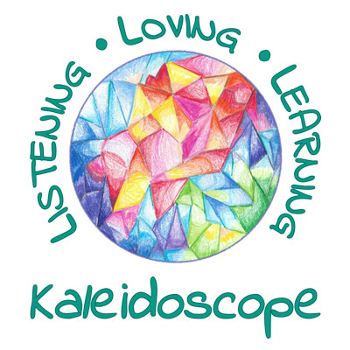

COMMUNITY OUTREACH PLAN
2019/2020

MONTH | CHARITY/ORGANIZATION | ITEMS/SERVICES  TO DONATE
August | Arizona Helping Hands  Back to School Drive  https://azhelpinghands.org/portfolio-items/how-to-help/ - back2school | School Supplies
September | Free Arts for the Abused and Homeless Children of Arizona  freeartsaz.org/ | Coin Drive
October | Friends of the Phoenix Public Library  plfriends.org/donate_books | Book Drive  New/Gently Used
November | St. Mary’s Food Bank  firstfoodbank.org/give/food/ | Canned Food  (Food Pyramid)
December | St. Vincent de Paul  stvincentdepaul.net/programs/adopt-a-family-christmas-program | Adopt a Family
January | Harvest Compassion Center  harvestcompassioncenter.org/ | Household Items  Baby Items
February | UMOM New Day Centers  umom.org/in-kind-donations/ | Dental Health Items
March | Goodwill Industries of Arizona  goodwill.org/donate/donate-stuff/ | Clothing Drive  New/Gently Used
April | Arizona Students Recycling Used Technology (AzStrut)  https://azstrut.org/our-mission/ | Used Electronics
May | Arizona Humane Society  azhumane.org/get-involved/give-now/ways-to-give/shelter-wishlist/ | Pet Supplies

